**Detailed Instructions for Data Dictionaries**

It is required to include a data dictionary (_dd.csv) for each csv file in a data package. However, the same data dictionary can be used for multiple csv files if they contain data structured in the same way. As mentioned in the detailed instructions for the terminology file, it may be useful to generate a master terminology file that includes the required (and optional) fields for all csv files and then pull from there the relevant fields for each _dd.csv file. Figure 1 shows an example of how a master terminology file could be structured to comply with the _dd.csv template as well as the terminology template (*i.e.*, by including the “Unit” and “Column_or_Row_Long_Name” fields, as well as “Term_Type”) in order to allow for a single master file collection of all terminology used within a data package/project/team etc.

The following instructions are from the [ESS-DIVE file level metadata reporting format](https://github.com/ess-dive-community/essdive-file-level-metadata) and are designed to facilitate File-level Metadata extraction of some fields using the [File Level Metadata Extractor](https://code.ornl.gov/ngee-arctic/ess-dive-meta).

1. Create a CSV data dictionary using the [CSV_dd_template](https://github.com/ess-dive-community/essdive-file-level-metadata/blob/master/CSV_dd/CSV_dd_template.csv). You can create either:  
    a. One data dictionary for each data file or  
    b. One data dictionary representing all data files in your dataset
2. See the [CSV_dd_quick_guide](https://github.com/ess-dive-community/essdive-file-level-metadata/blob/master/CSV_dd/csv_dd_quick_guide.md) for more details about completing the template
3. Enter a new row in the data dictionary for each column/row name in your data matrix  
    a. Use "*" wildcard when the description applies to multiple column/row names  
    b. For example - if the same description applies to all spectra data column names in the data file(s)  
    i. one row in the data dictionary can refer to "wave_*" and this definition will be understood to apply to multiple column names within a data sheet
4. View an example [CSV_dd_example](https://github.com/ess-dive-community/essdive-file-level-metadata/blob/master/CSV_dd/csv_dd_example.md)
5. Save the CSV_dd template following the [CSV Reporting Format guidance](https://github.com/ess-dive-community/essdive-csv-structure) with the filename "dd.csv" or "*_dd.csv". Alternatively you may choose to name you data dictionary:  
    a. With the same name as the associated data file, but include '_dd.csv' at the end of the file name  
    b. Create a unique filename for your data dictionary  
    c. Incorporate a wildcard into the filename if data dictionary applies to multiple data files (for example - "soil_cores_*_dd.csv")

Contents of the CSV_dd

For each variable provide the following:

* Column or Row Name
* Unit
* Definition
* Column or Row Long Name
* Data Type

Notes

Following the recommended format and structure of the CSV Reporting Format will facilitate File-level Metadata extraction of some fields using the [File Level Metadata Extractor](https://code.ornl.gov/ngee-arctic/ess-dive-meta).

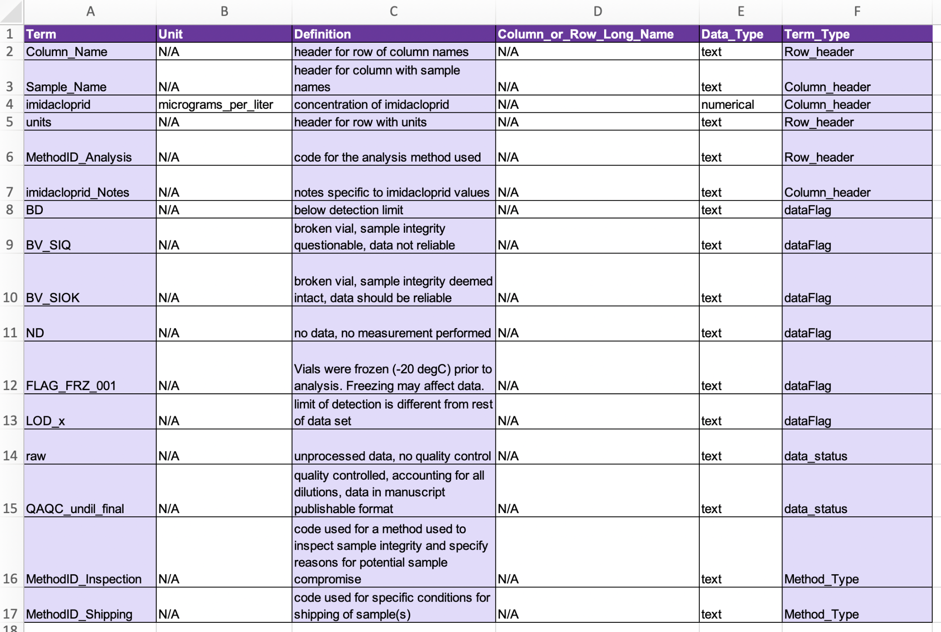

**Figure 1.** Example of a terminology file that is structured to include all terms used by a project (i.e. including headers etc that are required in the _dd.csv files) - i.e., serving as a complete dictionary. Note that the shaded fields are the only ones required for a terminology file included as part of a water-soil-sed-chem data package, and the unshaded (appearing white) fields are added because they are required in the _dd.csv files. If you prefer to keep the data dictionaries and the other terminology files separate, then disregard columns B and D above for the terminology file and remove column E (Term_Type) for the data dictionary files.